# 1: Introduction

The project is about to create a website for broadcasting company. The website will be developed to follow NBC news. This system will be developed using Microsoft Sharepoint and follow scrum methodology. Microsoft Sharepoint helps the users to accomplish their activities and task without difficulties. This project will be developed by a team. And here I am doing the job of the developer.

# 2: Sharepoint Architecture

Sharepoint architecture guide the users to accomplish their task without difficulty. It describes how the content will be structured and displayed. Sharepoint architecture make the system more usability and findability. Sharepoint architecture made many different elements. In my perspective I, Sharepoint made main 4 components those are site hierarchy, Navigation and search, taxonomy and security.

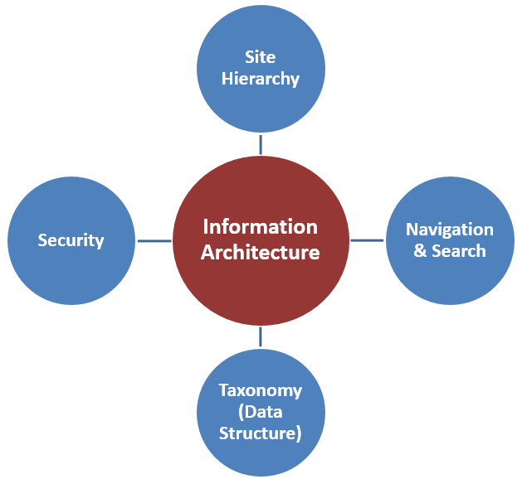

Figure 1system architecture (sharepointmaven, 2015).

In this project, I create easy navigation that makes the system usability and friendly. so that user accomplish their tasks without trouble.

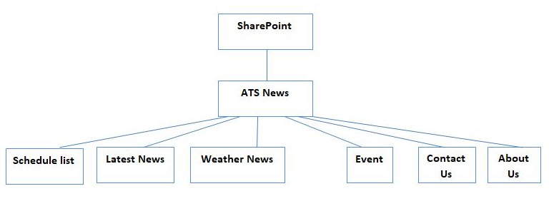

Figure 2: system architecture of this project

# 3: Evaluation of the product

## 3.1: System requirements

This broadcasting website will be developed by following NBC NEWS. This project will be created to follow the Scram methodology that helps us to complete the project at the right time. So, the scram master manages the project and created product backlog and etc. The analyst hardly tried to analysis the project so that this broadcasting company can be as much as same as the NBC news. After that, the designer designs the website by following design principles so that the design of the system can be user-friendly. And the database analyst designs the database of the system that helps a developer to develop this broadcasting website. As a developer I understand the requirements of the system and the system will be developed to follow these requirements. After that, the taster tests the system so that the system will be more user-friendly.

## 3.2: System functionality

* Owner can add and update program schedule.
* Owner can set Weather details and weather news.
* Latest news can be added by owner.
* Owner can add and update events.
* User can inquire and complaints.
* Owner add the company details and contact page for the user.

## 3.3: Assumptions

* The system will be responsive so the users can access the system from any device.
* The system can be verified all activities that make system’s strength.
* Owner can add user to the system.
* Data will be stored in Sharepoint’s database.

## 3.4: System walkthrough

This system will be developed for a broadcasting company there have the latest news, weather news, weather forecast, program schedule and etc. The owner can add, and post news and schedule and the user can inquiry and complaint through this system and they can see the news, schedule of program, weather and upcoming events. If the owner wants to add a member in this system, he can do this, and he can assign the member role. The owner can set upcoming events and upload files and documents.

## 3.5: System strength

* This system is highly secured because this system is developed by Microsoft Sharepoint.
* The system won’t be slow due to input large and more content.
* The owner can easily manage the system and accomplish tasks.
* The system is responsive so user can access from any device.

## 3.6: System weakness

* More validation could be done on the system.
* The system’s interface could be more effective and user-friendly.
* Weather reports could be created on the system.